An Introduction to GREEK AND ROMAN MYTHS
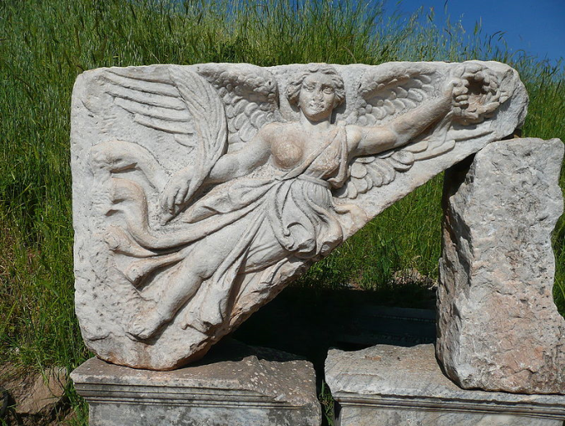
Have you ever been confused about a reference used in a work of literature or tried to figure out how a company chose a particular name for a product? Or maybe you have been mystified by the selection of a specific emblem used to represent a company’s name. Perhaps the problem was that you had nothing to use as a comparison to help you make the proper associations. For example, out of a multitude of names that could have been chosen for a tennis shoe, why would a company select the name NIKE™? If you knew that Nike was the name of a Roman Goddess of Victory, then you might have felt that the name was an appropriate one to use for a running shoe.
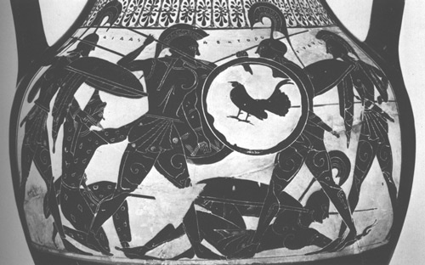
Also, AJAX™ would be a wise choice for the name of a cleaner because, according to the ancient Greeks, AJAX was a legendary hero who was noted for his strength and boldness. The symbol of a youth with a winged cap and winged feet used to promote the FTD Florist would be yet another good emblem to represent a business. However, if the consumer did not know that this emblem represented Hermes, who was a Greek god known for his speed, he or she would be incapable of figuring out that the emblem was used to express how quickly the company can make its delivery.
The same knowledge is needed to understand literature. A writer’s use of an allusion (a reference) to previous literary works or history helps to establish a link between the reader to the original reference. In other words, an allusion enhances the image of the message which is being conveyed so that the receiver can understand more easily. As heirs to the culture of our western civilization, we must be able to continue to pass these on to other generations. Furthermore, these references frequently show up not only in literature, but also in art, crafts, songs and dress. Most importantly, the knowledge of allusions can make a student’s work in higher education less difficult.
One of the most important foundations of literature in our western civilization is based on myths. Myths were primarily based on man’s basic need to explain the universe. They were also used to show how he was linked to his surroundings, as well as bow he struggled to know his place or role in connection with the natural order of things. Hence, myths symbolized ancient man’s idea of truth in exaggerated, romantic tales which boasted of the pursuits of adventurous gods and heroes. Because these myths were handed down orally, different accounts of these legends occurred through the years.

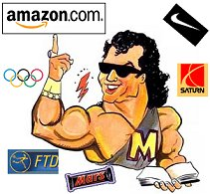
COMPANIES & GROUPS
Mythology is everywhere! There are hundreds of companies, groups and corporations that take their name, logo or theme from ancient mythology. I've provided a variety of examples to help you in starting your research. Some are well-known international companies, others are of a more local nature.
Aegis - Zeus and Athena's protective shield; modern group of insurance companies (The Aegis Group).
Ajax - Greek warrior in the Trojan War, who "cleaned up" in battle; popular household cleanser.
Amazon - Race of warrior women; amazon.com - huge on-line bookstore.
Apollo - God of music; Apollo Theater is a famous music hall in New York city.
Ares - Greek god of war; popular car model.
Argus - Giant watchman with a hundred eyes; Argus Security is a modern security company, specializing in commercial business protection.
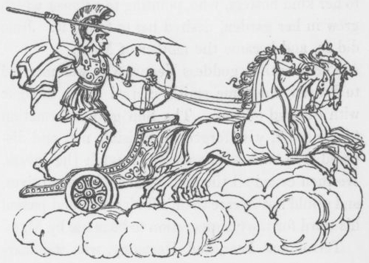
Atlas - Was doomed to support the heavens on his shoulders; a modern moving company (Atlas Van Lines); also, Atlas Travel is a popular name for travel agencies all over the globe.
Aurora - Roman name for Eos, goddess of the Dawn; luxury car model.
Charon - Boatman who ferries the souls of the dead to the Underworld; www.charon.com, a company "offering solutions for a connected world."
Delphi - Sanctuary to Apollo and home to his famous Oracles; Delphi Forums (www.delphi.com) is an on-line meeting place to promote discussions and to find answers. Delphi is also the name of an international Automotive Group.
Hercules - Roman name for Heracles, the greatest Greek hero; the company called Hercules - http://www.hercules.com - makes a top-selling video graphics card (their slogan is Legendary Strength, Quality and Performance);
there is also the Hercules transport plane, used by the United States Air Force to carry large volumes of war material and food;
Hercules Incorporated - http://www.herc.com - is a maker of chemicals and allied products.
Hermes - Olympian Herald and Messenger god; popular brand of soap. Also, the FTD flower delivery company incorporates Hermes and his winged heels in their logo.
Hyperion - Titan whose name means "he who goes before the sun"; a company (www.hyperion.com) that specializes in "business analysis software." Also the name of a book publishing company.
Hydra - Sea serpent with nine heads, killed by Hercules; It's the chosen name (www.hydra.com) of the Internet Chess Club.
Juno - Roman name for Hera, wife of Zeus; Juno is a popular web-hosting company (www.juno.com), specializing in free web pages and custom e-mail.
Mars - Roman name for Ares, god of War; name of popular candy bar.
Medusa - Terrible monster whose glance would petrify you, killed by the hero Perseus; Medusa Cement Company sells cement products worldwide.
Mercury - Roman name for Hermes, the Messenger god; name of car model produced by the Ford Motor Company; also, an entertainment records label, Mercury Records.
Midas - King with the golden touch, who transformed all he touched to gold; a famous muffler and brake chain of service stations.
Minerva - Roman name for Athena, who gifted the olive tree to humans; Minerva Oil Company is an international exporter of fine food products.
Nike - Winged goddess of Victory, who can run and fly at great speeds; a famous company that sells...well...if you haven't heard of the company Nike, welcome to our planet...:)
Odyssey - The 10-year sea voyage endured by the Trojan War hero, Odysseus, as he sought to return home to Ithica; Odyssey Travel is a well-known travel agency; Odyssey Cruise Lines is a cruise company; Odyssey Records is a record company; there's even an Odyssey Golf Club company...you get the drift, Odyssey is a very popular modern mythological rip-off...
Olympus - Home of the Olympian gods; name of popular camera and photographic technology company. Also, Olympic Airlines is another variation of the name. (Note: Thanasi's Olympus Greek Restaurant is owned by the Myth Man...)
Orion - A giant hunter slain by Artemis in Greek mythology; a motion picture production company, Orion Pictures.
Pandora - The first woman in Greek mythology, whose name means "all-gifted"; Pandora's Gift Boutique sells quality gift merchandise.
Parthenon - The temple of Athena, built on the Acropolis of Athens; perhaps the most-used name for any Greek restaurant in any city of the world! It's ridiculous...I bet there's a Parthenon Restaurant in your town! :)
Pegasus - Winged horse that was born from Medusa's head when she was killed; Pegasus Expedite Company is a national delivery/courier service; Pegasus Satellite Systems is a provider of satellite entertainment services. The winged horse motif is used by dozens of companies. Check out my Pegasus Homework Help page for more on that.
Phoenix - A mythical and one-of-a-kind bird that burns on a funeral pyre after a life of hundreds of years, only to be re-born from the ashes; also the name of a national photographic technology company.
Poseidon - God of the Sea and brother of Zeus; Poseidon Travel is a common travel agency name; Poseidon Seafood is a national brand of seafood products. Neptune, the Roman version, is often also used by companies, as in Neptune Fresh Lobster Co.
Saturn - Roman name for Cronus, father of Zeus; also the name of the Saturn Automobile Corporation.
Titans - Race of gods preceding the Olympians; Titan Tool & Die Company manufactures tools for industry.
Trident - The three-pronged spear of Poseidon, god of the seas; Trident Gum is a popular gum. (Note: 'Tria' is Greek for 'three' and 'donti' means 'tooth'; hence, Trident translates literally as 'three-teeth', or 'triple-toothed'. Trident Gum, if one is to believe the advertising, helps to clean your teeth, thus the allusion.)
Spartan - Greek warrior state, devoted to discipline and the martial arts; Spartan Corporation is a financial advisory company; also, Spartan Tool & Die is a national manufacturer and supplier to the auto industry; Spartan Nutritional Products is a maker and distributor of health supplements.
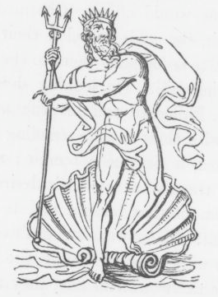
Trojan - Inhabitants of the mighty city that was destroyed by the Greeks during the Trojan War, after a siege of ten years; international manufacturer of condoms and birth control products.
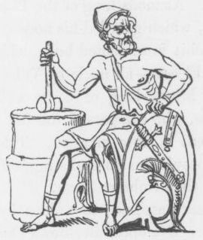
Venus - Roman for Aphrodite, goddess of beauty and love; Venus is the name of a famous beauty product company; Venus International is a popular beauty talent agency; Venus Tan Lines is a swimsuit manufacturer; Venus Razor is a popular women's shaving accessory; Venus Beauty Salon is found in most any city or town...
Vulcan - Roman name for Hephaestus, god of the smiths and the forge; Vulcan Industries is an international manufacturer of steel products.
These are but a few of the examples of companies or groups that take their name, logo or theme from mythology.

